Explain R Nuts and bolts in detail. 6 marks
R is the most comprehensive statistical analysis package available. It incorporates all of the standard statistical tests, models, and analyses, as well as providing a comprehensive language for managing and manipulating data.

- R is a programming language and environment developed for statistical analysis by practising statisticians and researchers. It reflects well on a very competent community of computational statisticians.
- The graphical capabilities of R are outstanding, providing a fully programmable graphics language that surpasses most other statistical and graphical packages.
- R is free and open-source software, allowing anyone to use and, importantly, to modify it. R is licensed under the GNU General Public License, with copyright held by The R Foundation for Statistical Computing.
- R has no license restrictions (other than ensuring our freedom to use it at our own discretion), and so we can run it anywhere and at any time.
- Anyone can provide new packages, and the wealth of quality packages available for R is a testament to this approach to software development and sharing.
- R has over 4800 packages available from multiple repositories specializing in topics like econometrics, data mining, spatial analysis, and bio-informatics.
- R is cross-platform. R runs on many operating systems and different hardware. It is popularly used on GNU/Linux, Macintosh, and Microsoft Windows, running on both 32 and 64 bit processors.
- R plays well with many other tools, importing data, for example, from CSV files, SAS, and SPSS, or directly from Microsoft Excel, Microsoft Access, Oracle, MySQL, and SQLite.
- It can also produce graphics output in PDF, JPG, PNG, and SVG formats, and table output for LATEX and HTML.
- R has active user groups .

1. Developed for statistical analysis
2. Outstanding graphical capabilities
3. New packages available
4. 4800 existing packing
5. R is open source and free
6. License free so anytime, anywhere
7. Cross platform( OS)
8. Can integrate many other tools
9. Can produce graphical output
10. Active user community

2. What are different data types supported in R. Explain them in brief 7 marks

NUMERIC, INTEGER, CHARACTER, LOGICAL: Data types represent the structure of the data stored and manipulated within the environment.
- Numeric Description: Numeric data types store numbers, which can be either integers or real (floating-point) numbers.
Example:
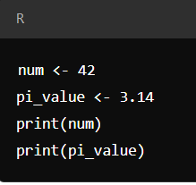
Usage: Used for mathematical calculations, statistical analysis, and operations involving numbers.

- Integer
Description: Integers are whole numbers without decimal points. In R, integers are explicitly defined using the as.integer() function.
Example:
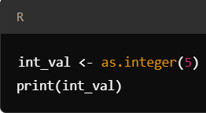
Usage: Used when precise integer values are required.

- Character(String)
Description: Character data type is used to store text strings, which can include letters, words, or sentences.
Example:
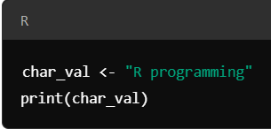
Usage: Useful for storing and processing text data, labels, and categorical values.

- Logical
Description: Logical data types store Boolean values, which are either TRUE or FALSE. These are often the result of logical conditions or comparisons.
Example:
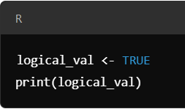
Usage: Used in control flow, logical operations, or data filtering based on conditions.

- Complex
Description: Complex numbers in R have a real and an imaginary part. They are written in the form a + bi, where i is the imaginary unit.
Example:
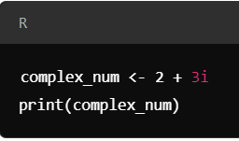
Usage: Useful for advanced mathematical operations that require imaginary numbers.

Q) Different data types supported in R. Explain them in brief

NUMERIC | INTEGER | CHARACTER, | LOGICAL | COMPLEX NUMBERS
- Numeric data types store numbers, which can be either integers or real (floating-point) numbers. | Integers are whole numbers without decimal points. In R, integers are explicitly defined using the as.integer() function. | Character data type is used to store text strings, which can include letters, words, or sentences. | Logical data types store Boolean values, which are either TRUE or FALSE. These are often the result of logical conditions or comparisons. | Complex numbers in R have a real and an imaginary part. They are written in the form a + bi, where i is the imaginary unit.
Usage: Used for mathematical calculations, statistical analysis, and operations involving numbers. | Usage: Useful for storing and processing text data, labels, and categorical values. | Usage: Used in control flow, logical operations, or data filtering based on conditions. | Usage: Used in control flow, logical operations, or data filtering based on conditions. | Usage: Useful for advanced mathematical operations that require imaginary numbers.

Explain different ways of reading data in R (5 marks)
read.table()
read.csv()
readLines()
source()
load()
dget()
unserialize()
- read.table() and read.csv()
  - read.table(): Reads data from a file in tabular format (like CSV, TSV). You can specify delimiters using the sep
data <- read.table("data.txt", header = TRUE, sep = "\t")

  - read.csv(): A specific version of read.table() for reading comma-separated value files (CSV).
data <- read.csv("data.csv", header = TRUE)

- readLines()
This function reads lines from a text file,
making it useful for non-tabular or unstructured data.
  - readLines(file) – Reads each line as a character string and returns a vector of lines.
3. source()
- Purpose: Loads and executes R code from an external file. This is typically used to run entire R scripts stored in separate files.
source("script.R") # Executes the R code in 'script.R'

dget()
- Purpose: Reads and reconstructs an R object that was saved using dput(). This is useful for restoring R objects stored in a readable text format.
object <- dget("object.txt")

4. load()
- Purpose: Loads an R workspace or .RData file containing multiple saved objects (e.g., data frames, lists, models). This restores all objects in the file into the R environment.
load("workspace.RData")

5. unserialize()
- Purpose: Reads and reconstructs a single R object from a binary format, typically used for more advanced applications. It is generally used for serializing and unserializing R objects, such as for saving R objects in binary files.
object <- unserialize("data.bin")

State the different principal functions used to get the data into & out of R. (in is in prev q)

a) write.table()
- Purpose: Writes data to a text file, with options for separators (e.g., tabs, spaces).
Usage:
write.table(data, "output.txt", sep = "\t", row.names = FALSE)

b) write.csv()
- Purpose: Writes data to a CSV file.
Usage:
write.csv(data, "output.csv", row.names = FALSE)

c) write.csv2()
- Purpose: Writes data to a CSV file with semicolon delimiters (common in Europe).
write.csv2(data, "output.csv", row.names = FALSE)

d) write.delim()
- Purpose: Writes data to a tab-delimited file.
Usage:
write.delim(data, "output.txt", row.names = FALSE)

e) writeLines()
- Purpose: Writes data line by line to a text file.
Usage:
writeLines(lines, "output.txt")

f) save()
- Purpose: Saves multiple R objects into a .RData file.
- Usage:
save(data, object, file = "workspace.RData")

Name and Explain the following 8 marks

Basic Operations

Basic statistical operations pertaining to R

Basic Operations in R ******
1.arithmetic operations
2.logical operations
3.relational operators
4.assignment operators
5.indexing and slicing operations

- Arithmetic operations
These include addition (+), Subtraction (-), Multiplication (*), Division (/) and exponentiation
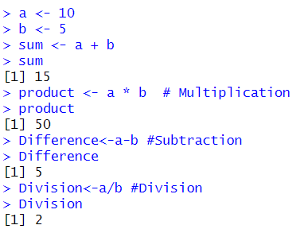
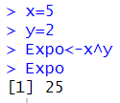
- Relational Operations
These are used for comparison and include greater than( >) or less than (<) and equal to(==) or not equal to (!=)
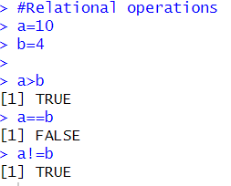

- Logical operations
Logical operations include AND(&) OR(|) and NOT (!)

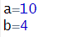
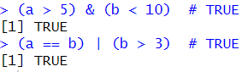
- Assignment operations
R uses assignment operator to assign values to the variable
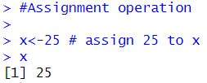

- Indexing and slicing
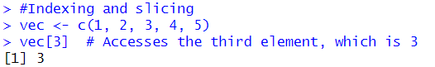

Basic statistics pertaining to R
R provides built-in functions to perform common statistical operations on data.
  - Mean:
The mean is the average value of a data set. You can calculate the mean using the mean() function.
Example:
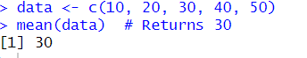
  - Median:
The median is the middle value of a data set. Use the median() function to find it.
Example:
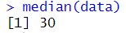
  - Mode:
R doesn’t have a built-in function for mode, but it can be calculated manually using custom code.
  - Variance:
Variance measures the spread of data. It is calculated using the var() function. Example:
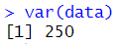
  - Standard Deviation:
The standard deviation is the square root of the variance and can be calculated using sd().
Example:
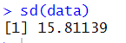
  - Summary Statistics:
R provides the summary () function, which gives an overview of the basic statistics for data, including minimum, first quartile, median, mean, third quartile, and maximum.
Example:

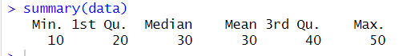

  - Correlation and Covariance:
You can calculate the correlation and covariance between two variables using cor() and cov().
Example:

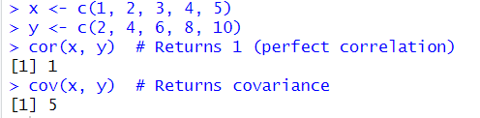

What are factors in R-language? How are they created? How are they modified? Explain with R code. 6 marks

- Factors in R are data structures used to represent categorical data.
- They store both the values and the corresponding levels (categories).
- Factors are particularly useful for statistical modelling where categorical variables are treated as distinct levels, rather than numerical values.
- Factors are commonly used to represent variables such as gender, country, education level, etc., where the values belong to specific, predefined categories.

Key Characteristics
- Stored as integers with unique levels.
- Have a levels attribute representing categories.
- Can be ordered or unordered:
  - Ordered factors have a specific sequence (e.g., "Low" < "Medium" < "High").
  - Unordered factors treat all levels as equal.

Creating Factors in R
You can create factors using the factor() function. Here's an example:
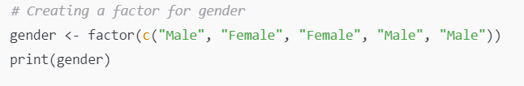
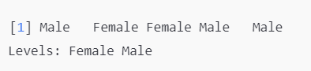
Specifying Levels Manually
You can also manually specify the levels of a factor.

Ordered Factors
R
Copy code
# Example 3: Ordered Factor
priority <- factor(c("Low", "High", "Medium", "Low"),
levels = c("Low", "Medium", "High"),
ordered = TRUE)
print(priority)
# Output: Levels: Low < Medium < High

Modifying Factors in R
Once a factor is created, you can modify its levels or values in different ways.
Example : Renaming Factor Levels
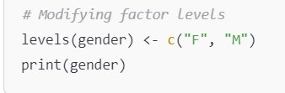
In this example, the levels of gender are renamed from "Female" and "Male" to "F" and "M", respectively.
Adding or Dropping Levels
You can also add or drop levels when modifying factors.
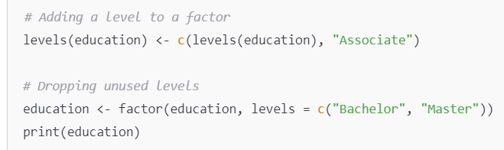
In this example, we first add a new level "Associate" to the education factor, then drop unused levels to only retain "Bachelor" and "Master".

Adding or Dropping Levels
R
Copy code
# Example 5: Adding and Dropping Levels
education <- factor(c("Bachelor", "Master", "Bachelor"))
# Add a new level
levels(education) <- c(levels(education), "Associate")
print(education)
# Drop unused levels
education <- droplevels(education)
print(education)

- Describe most commonly used data plots for statistical analysis in R language. 6 marks

In R, data visualization plays a critical role in understanding the patterns, trends, and relationships within the data. Several types of plots are frequently used for statistical analysis, and R provides powerful functions for creating these plots. Below are the most commonly used data plots, along with their purposes and examples:

- Scatter Plot
used to visualize the relationship between two continuous variables.
They help identify potential correlations or patterns such as linear or non-linear relationships.

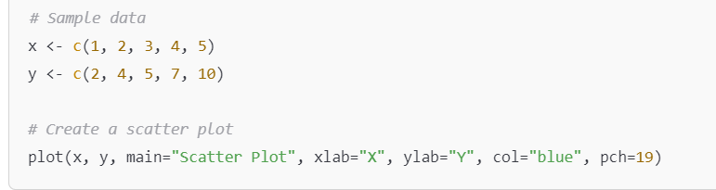
- Interpretation: Each point represents an observation's values for two variables. You can assess the strength and direction of the relationship (positive, negative, or no correlation).

- Box Plot
Box plots (or box-and-whisker plots) are used to visualize the distribution of a variable and to identify outliers.
They summarize data in terms of quartiles and highlight the median, interquartile range, and outliers.
basic box plot

# Data
data <- c(7, 8, 8, 7, 10, 6, 9, 8, 9, 6)

# Boxplot
boxplot(data,
main = "Basic Boxplot",
ylab = "Values",
col = "lightblue")
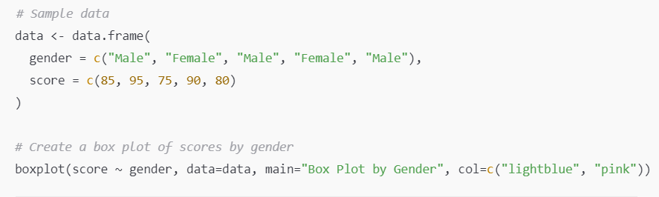

Interpretation: The box represents the interquartile range (middle 50% of data),
the line inside the box is the median,
The whiskers extend to the minimum and maximum values within 1.5 times the IQR from Q1 and Q3, respectively:
- Lower whisker: Q1 - 1.5 * IQR (or the smallest value within this range).
- Upper whisker: Q3 + 1.5 * IQR (or the largest value within this range).
Outliers appear as individual points.

- Histogram
Show the distribution of a continuous variable.
They display the frequency of data points that fall within certain ranges (or bins).

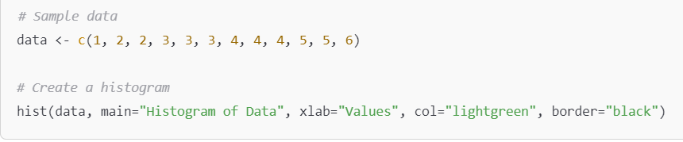
Interpretation: The height of each bar represents the number of observations within each bin. The shape of the histogram reveals the distribution of the data (e.g., normal, skewed).

- Bar Plot
Bar plots are used to represent categorical data.
Each bar’s height represents the frequency or count of a category.
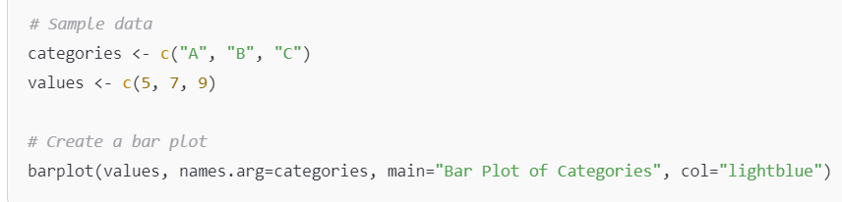
- Interpretation: Bar plots show the frequencies of different categories. They are useful for comparing the counts of different groups.

- Line Plot
Line plots are used to visualize trends over time or other ordered data. They are commonly used in time series analysis.
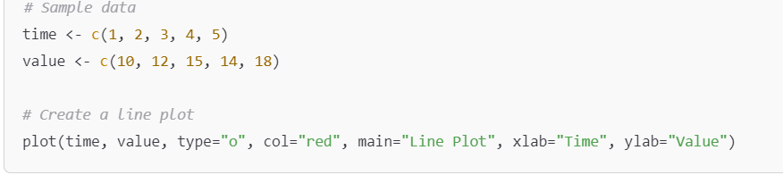
- Interpretation: The line connects data points, making it easy to identify trends, peaks, and dips over time.

- Density Plot
A density plot is a smoothed version of a histogram and is used to visualize the distribution of a continuous variable.
It estimates the probability density function of the variable.

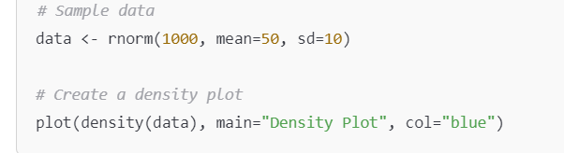
Interpretation: The shape of the density plot helps you understand the underlying distribution of the data, including any skewness or multimodality.

- With reference to the data frames in R language
  - Create a simple data frame from 3 vectors. Order the entire data frame by first column
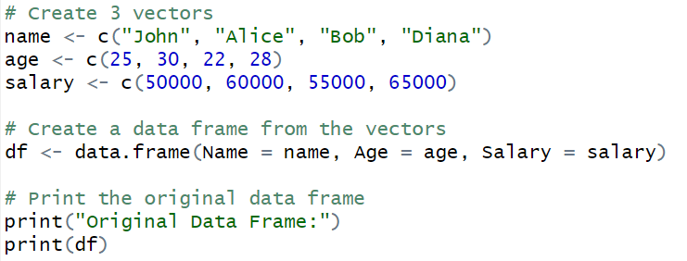

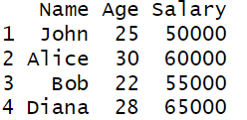

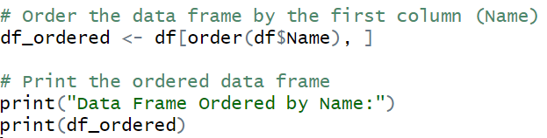

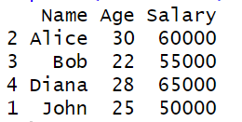
  - Create a data frame from a matrix of your choice, change the row names so every row says id_i (where i is the row number) and change the column names to variable_i (where i is the column number). i.e., for column 1 it will say variable_1, and for row 2 will say id_2 and so on.

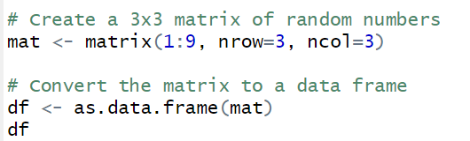

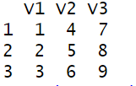

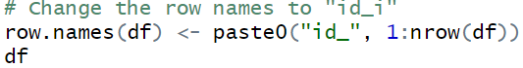
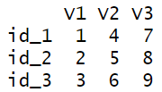
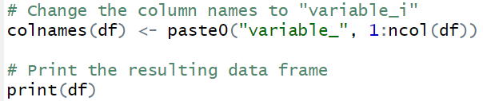
Matrix Creation: A 3x3 matrix is created using the matrix() function.
Convert to Data Frame: The matrix is converted to a data frame using as.data.frame().
Change Row Names: The row.names() function is used to assign new row names in the format id_i, where i is the row number.
Change Column Names: The colnames() function is used to assign new column names in the format variable_i, where i is the column number.
paste0(): This function is used to concatenate strings. It joins "id_" or "variable_" with the row or column numbers.

- Summarize the operations that can be performed on a data frame in R language.
8 marks
A data frame in R is a widely used data structure for storing datasets in a tabular form, where columns represent variables, and rows represent observations. Data frames are highly versatile and offer various operations for data manipulation, analysis, and transformation. Below are the key operations that can be performed on a data frame in R:

1. Creating a Data Frame
You can create a data frame using the data.frame() function by combining vectors of equal lengths
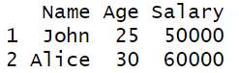
2. Accessing Elements of a Data Frame
You can access rows, columns, or individual elements using indexing or column names.
- Accessing columns: By column name or index.
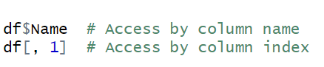
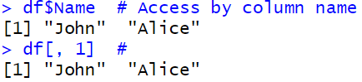
3. Accessing specific elements:
3. Adding Columns or Rows
You can add new columns or rows to an existing data frame.
Adding a new column:
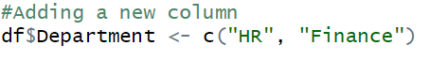
Adding a new row (using rbind()):
4. Modifying Columns or Rows
You can modify existing elements in a data frame by direct assignment.
Modify a column:
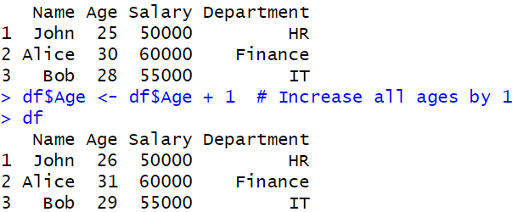
Modify specific row
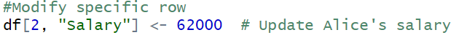
- Filtering Data (Subsetting)
You can filter or subset a data frame based on conditions using logical indexing or the subset() function.
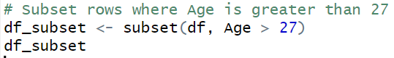

- Sorting a Data Frame
You can sort a data frame by a specific column using the order() function.
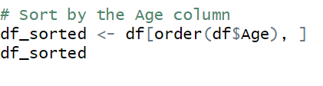
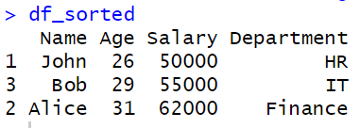

- Summary and Statistical Operations
R provides functions to summarize and compute statistics on data frames.
Summary of the data frame:
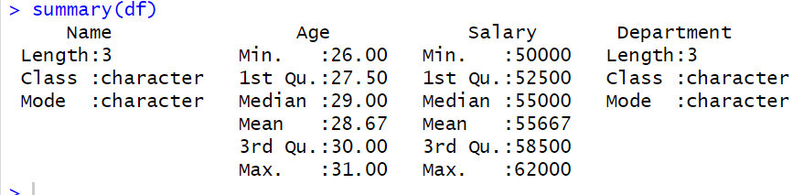

Mean of a numeric column:
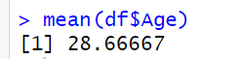
- Merging Data Frames
You can merge two data frames using the merge() function, which works like a SQL join.
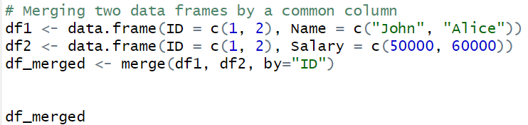

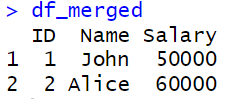

- Point out the functions which are used for the conversion of covariance to correlation in R. Explain the function with syntax and sample data.
In R, the conversion of a covariance matrix to a correlation matrix can be done using the cov2cor() function. This function takes a covariance matrix as input and returns the corresponding correlation matrix.
cov2cor() Function
cov2cor(V)
V: A square covariance matrix.
Explanation:
The cov2cor() function standardizes the covariance matrix into a correlation matrix by dividing each covariance by the product of the standard deviations of the variables. A correlation matrix shows the strength and direction of the linear relationships between variables, while a covariance matrix reflects the variance and covariances in raw units.
2. Example with Sample Data
Let's demonstrate with a sample dataset of two variables: x and y.
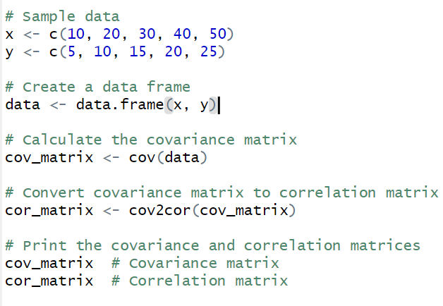
Explanation:
- cov(): This function computes the covariance matrix for the given data. In this case, cov(data) computes the covariance between x and y.
- cov2cor(): This function converts the covariance matrix into a correlation matrix, where the diagonal elements will be 1, and the off-diagonal elements will represent the correlation coefficients between variables.

(i) length()
Purpose: Returns the number of elements in a vector or list
# Example
x <- c(10, 20, 30, 40)
length(x) # Output: 4 (4 elements in the vector)

(ii) count()
Purpose: Used with dplyr to count occurrences in a data frame column.
# Example (requires dplyr package)
library(dplyr)
df <- data.frame(
Group = c("A", "B", "A", "C", "B", "A")
)
count(df, Group)
# Output:
# Group n
# 1 A 3
# 2 B 2
# 3 C 1

(iii) mean()
Purpose: Calculates the average (mean) of a numeric vector.
# Example
x <- c(10, 20, 30, 40)
mean(x) # Output: 25 (Sum = 100, Count = 4, Mean = 100 / 4)

(iv) var()
Purpose: Computes the variance, measuring how far the data points are spread from the mean.
# Example
x <- c(10, 20, 30, 40)
var(x) # Output: 166.67 (Measures variability in data)

(v) sd()
Purpose: Calculates the standard deviation, which is the square root of the variance.
# Example
x <- c(10, 20, 30, 40)
sd(x) # Output: 12.91 (Measures average spread from the mean)

(vi) median()
Purpose: Returns the middle value of a sorted vector.
# Example
x <- c(10, 20, 30, 40)
median(x) # Output: 25 (Middle value in sorted data: (20 + 30) / 2)

(vii) min()
Purpose: Finds the smallest value in a vector.
# Example
x <- c(10, 20, 30, 40)
min(x) # Output: 10 (Smallest value)

(viii) max()
Purpose: Finds the largest value in a vector.
# Example
x <- c(10, 20, 30, 40)
max(x) # Output: 40 (Largest value)

(ix) quantile()
Purpose: Computes specific percentiles of a numeric vector.
# Example
x <- c(10, 20, 30, 40)
quantile(x, probs = c(0.25, 0.5, 0.75))
# Output:
# 25% 50% 75%
# 17.5 25.0 35.0
# (Q1, Median, and Q3)

(x) IQR()
Purpose: Calculates the Interquartile Range (IQR), the difference between Q3 and Q1.
# Example
x <- c(10, 20, 30, 40)
IQR(x) # Output: 17.5 (IQR = Q3 - Q1 = 35 - 17.5)

Perform the following operation in data frame:

- [ ] i).Write a R program to add a new column in a given data frame.

- [ ] ii). Write a R pr0gram to add new row(s) to an existing data frame.

- [ ] iii).Write a R program to drop column(s) by name from a given data frame.

- [ ] iv).Write a R program to drop row(s) by number from a given data frame.

(i) Add a New Column to a Data Frame
# Create a sample data frame
df <- data.frame(
Name = c("Alice", "Bob", "Charlie"),
Age = c(25, 30, 35)
)

# Add a new column
df$Gender <- c("Female", "Male", "Male")

# Print updated data frame
print(df)
# Output:
# Name Age Gender
# 1 Alice 25 Female
# 2 Bob 30 Male
# 3 Charlie 35 Male

(ii) Add New Row(s) to an Existing Data Frame
# Create a sample data frame
df <- data.frame(
Name = c("Alice", "Bob", "Charlie"),
Age = c(25, 30, 35),
Gender = c("Female", "Male", "Male")
)

# Add a new row
new_row <- data.frame(Name = "Diana", Age = 28, Gender = "Female")
df <- rbind(df, new_row)

# Add multiple rows
more_rows <- data.frame(Name = c("Eve", "Frank"), Age = c(24, 29), Gender = c("Female", "Male"))
df <- rbind(df, more_rows)

# Print updated data frame
print(df)
# Output:
# Name Age Gender
# 1 Alice 25 Female
# 2 Bob 30 Male
# 3 Charlie 35 Male
# 4 Diana 28 Female
# 5 Eve 24 Female
# 6 Frank 29 Male

(iii) Drop Column(s) by Name from a Data Frame

# Create a sample data frame
df <- data.frame(
Name = c("Alice", "Bob", "Charlie"),
Age = c(25, 30, 35),
Gender = c("Female", "Male", "Male")
)

# Drop a column by name
df <- subset(df, select = -Gender)

# Drop multiple columns by name
df <- subset(df, select = -c(Name, Age))

# Print updated data frame
print(df)
# Output after dropping Gender:
# Name Age
# 1 Alice 25
# 2 Bob 30
# 3 Charlie 35

(iv) Drop Row(s) by Number from a Data Frame
R
Copy code
# Create a sample data frame
df <- data.frame(
Name = c("Alice", "Bob", "Charlie"),
Age = c(25, 30, 35),
Gender = c("Female", "Male", "Male")
)

# Drop a row by number (e.g., 2nd row)
df <- df[-2, ]

# Drop multiple rows by number (e.g., 1st and 3rd rows)
df <- df[-c(1, 3), ]

# Print updated data frame
print(df)
# Output after dropping 2nd row:
# Name Age Gender
# 1 Alice 25 Female
# 3 Charlie 35 Male

3 generic functions

1. summary()
- Provides a summary of an object.
- Behavior changes depending on the class of the object (e.g., numeric vector, data frame, or model).
Example:
R
Copy code
# Numeric vector
x <- c(1, 2, 3, 4, 5)
summary(x)
# Output:
# Min. 1st Qu. Median Mean 3rd Qu. Max.
# 1 2 3 3 4 5

# Data frame
df <- data.frame(Age = c(25, 30, 35), Gender = c("Male", "Female", "Male"))
summary(df)
# Output:
# Age Gender
# Min. :25.0 Female:1
# 1st Qu.:27.5 Male :2
# Median :30.0
# Mean :30.0
# 3rd Qu.:32.5
# Max. :35.0

2. plot()
- Creates a plot of the input data.
- The type of plot varies depending on the object (e.g., scatterplot for two vectors, boxplot for data frames).
# Scatter plot of numeric vectors
x <- c(1, 2, 3, 4, 5)
y <- c(2, 4, 6, 8, 10)
plot(x, y, main = "Scatter Plot", xlab = "X values", ylab = "Y values")

# Boxplot of a data frame column
df <- data.frame(Scores = c(90, 85, 78, 92, 88))
plot(df$Scores, main = "Boxplot of Scores")

3. print()
- Displays an object in the console.
- Behavior changes depending on the object's class (e.g., prints matrix differently than a list).
Example:
R
Copy code
# Print a vector
x <- c(1, 2, 3)
print(x)
# Output:
# [1] 1 2 3

# Print a list
my_list <- list(Name = "Alice", Age = 25, Scores = c(90, 85, 80))
print(my_list)
# Output:
# $Name
# [1] "Alice"
#
# $Age
# [1] 25
#
# $Scores
# [1] 90 85 80

Explain the function available in R programming language used to determine the relation between two attributes.

1. cor() - Correlation
The cor() function is used to compute the correlation coefficient between two variables. The correlation coefficient measures the strength and direction of the linear relationship between two numeric variables. It ranges from -1 to 1, where:
- 1 indicates a perfect positive linear relationship.
- -1 indicates a perfect negative linear relationship.
- 0 indicates no linear relationship.
Syntax:
cor(x, y, method = c("pearson", "kendall", "spearman"))
- x and y are numeric vectors or columns in a data frame.
- method specifies the type of correlation: "pearson", "kendall", or "spearman".
Example:

# Example data
x <- c(1, 2, 3, 4, 5)
y <- c(2, 4, 6, 8, 10)

# Calculate Pearson correlation
cor(x, y) # Output: 1 (Perfect positive correlation)

2. cov() - Covariance
The cov() function computes the covariance between two variables. Covariance is similar to correlation but does not standardize the relationship. It indicates the direction of the relationship, but its magnitude is not standardized.
Syntax:
cov(x, y)

- x and y are numeric vectors or columns in a data frame.
Example:
# Example data
x <- c(1, 2, 3, 4, 5)
y <- c(2, 4, 6, 8, 10)

# Calculate covariance
cov(x, y) # Output: 5 (Positive covariance, indicates they move in the same direction)

4. plot() - Scatter Plot
The plot() function is often used to visualize the relationship between two variables through a scatter plot. It helps to visually inspect if there is a linear, non-linear, or no relationship between the variables.
Syntax:
plot(x, y)

Explain with Step-by-Step procedure for the evaluation of machine language models in R language.

Explaan R code implementation of KNN algorithm

# Step 1: Load Libraries
library(class) # For KNN
library(caret) # For confusionMatrix

# Step 2: Load Data and Split
data(iris)
set.seed(123)
trainIndex <- createDataPartition(iris$Species, p = 0.8, list = FALSE)
trainData <- iris[trainIndex, ]
testData <- iris[-trainIndex, ]

# Step 3: Apply KNN
k_value <- 3 # Number of nearest neighbors
model_knn <- knn(trainData[, -5], testData[, -5], trainData$Species, k = k_value)

# Step 4: Evaluate Model
conf_matrix <- confusionMatrix(model_knn, testData$Species)
print(conf_matrix)

Explain how a decision tree model is built using R programming language. Also show commands to plot a tree.
# Step 1: Load Libraries
library(rpart) # For decision tree
library(rpart.plot) # For plotting the tree
library(caret) # For confusionMatrix

# Step 2: Load Data and Split
data(iris)
set.seed(123)
trainIndex <- createDataPartition(iris$Species, p = 0.8, list = FALSE)
trainData <- iris[trainIndex, ]
testData <- iris[-trainIndex, ]

# Step 3: Build Decision Tree
tree_model <- rpart(Species ~ ., data = trainData, method = "class")

# Step 4: Evaluate Model
predictions <- predict(tree_model, testData, type = "class")
conf_matrix <- confusionMatrix(predictions, testData$Species)
print(conf_matrix)

# Step 5: Plot the Decision Tree
rpart.plot(tree_model)

